|  |
| --- |
|  |
| Problem Statement |

# Problem Statement

AppleBite Co. is using Cloud for one of their products. The project uses modular components, multiple frameworks and want the components to be developed by different teams or by 3rd-party vendors.

The company’s goal is to deliver the product updates frequently to production with High quality & Reliability. They also want to accelerate software delivery speed, quality and reduce feedback time between developers and testers.

As development progressed, they are facing multiple problems, because of various technologies involved in the project. Following are the problems:

* Building Complex builds is difficult
* Incremental builds are difficult to manage, and deploy

To solve these problems, they need to implement Continuous Integration & Continuous Deployment with DevOps using following tools:

**Git** – For version control for tracking changes in the code files **Jenkins** – For continuous integration and continuous deployment **Docker** – For deploying containerized applications

**Ansible** - Configuration management tools

This project will be about how to do deploy code to dev/stage/prod etc, just on a click of button. Link for the sample PHP application: https://github.com/edureka-devops/projCert.git

# Business challenge/requirement

As soon as the developer pushes the updated code on the GIT master branch, a new test server should be provisioned with all the required software. Post this, the code should be containerized and deployed on the test server.

The deployment should then be built and pushed to the prod server.

All this should happen automatically and should be triggered from a push to the GitHub master branch.

Steps for executing the solution:

* + Use the Master VM for Jenkins, Ansible, GIT etc.
  + Use the fresh instance for Jenkins Slave Node (Test Server)
  + Change the IP address of the VMs accordingly
  + Add Build Pipeline Plugin and Post-build task plugin to Jenkins on the master VM
  + Install python, openssh-server and git on the slave node manually
  + Use the image devopsedu/webapp and add your PHP website to it using a Dockerfile
  + Push the PHP website, and the Dockerfile to a git repository Below tasks should be automated through Jenkins by creating a pipeline:

1. Install and configure puppet agent on the slave node (Job 1)
2. Push an Ansible configuration on test server to install docker (Job 2)
3. Pull the PHP website, and the Dockerfile from the git repo and build and deploy your PHP docker container. After. (Job 3)
4. If Job 3 fails, delete the running container on Test Server

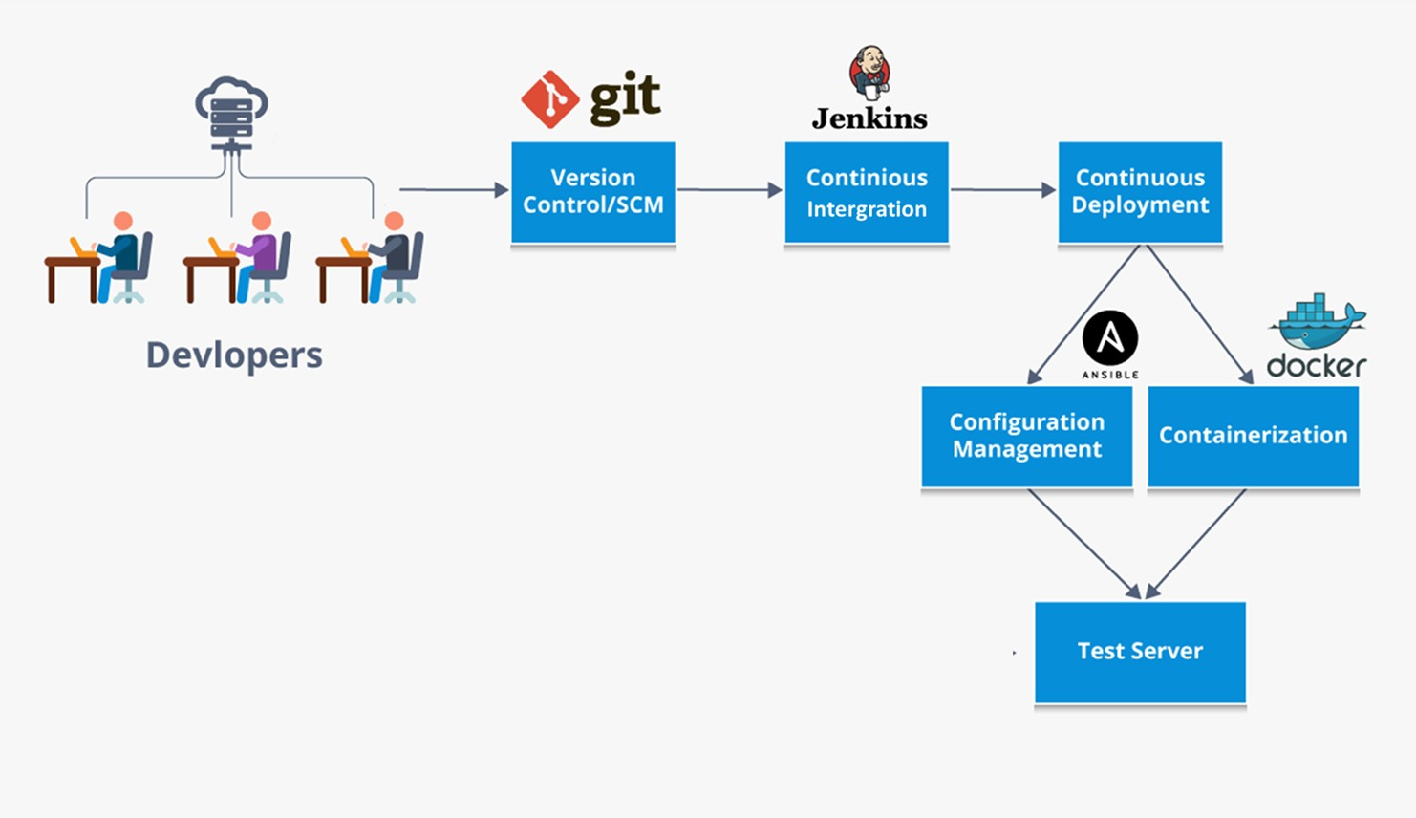

**System Requirements:**

Gitlab setup — free account

Jenkins master - VM1

Build server - VM1

Monitoring framework - VM2

Production server – VM2